Contents
Overview 1
Add or Edit a Holiday Scheme Override 1
Delete a Holiday Scheme Override 2
Maintain and Track Override 3

Overview

The Workgroup Override allows the user to override certain workgroup settings at an employee level.

Currently the only override setting being utilised is the Holiday Scheme. The Holiday Scheme calculates when an employee is allowed to book leave and this is derived from the workgroup as default. In certain circumstances where multiple employees share the same workgroup, but have differing holiday terms, then the Holiday Scheme against the workgroup can be overridden at employee level and these are the steps covered in this guide.

 | NB: To complete this process the following menu options must be enabled:  ‘WFM Admin > Person Maintenance > Work Group Override’  ‘WFM Admin > Person Maintenance > Add/Update Work Group Override’.

Add or Edit a Holiday Scheme Override

- Login to PeopleXD
- Navigate to the WFM Admin Dashboard > WFM Person Maintenance
- Locate the individual employee. Where employees hold multiple appointments, ensure you select the relevant Appointment ID.
- Click on the 3 dots ellipses and select ‘View’.
- Select the Work Group Override tab.

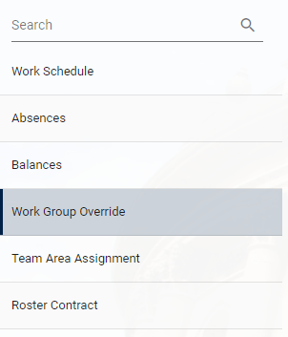

- Under Work Group Setting, you will see Holiday Scheme. The default Holiday Scheme, which pulls in from the workgroup is displayed under Work Group Value. If an override has already been set, this will be displayed under Person Override Value.

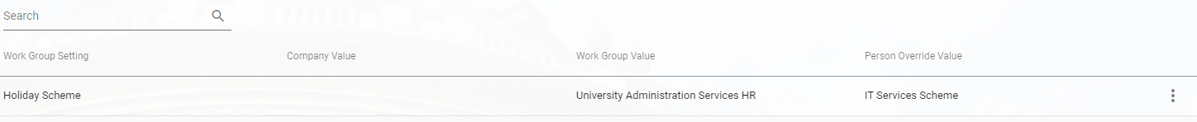

- Click on the 3 dots ellipses to the right of Holiday Scheme.
- Select Edit Override.
- Enter the holiday scheme that you want to set as the override, and then click OK.

Delete a Holiday Scheme Override

- Login to PeopleXD
- Navigate to the WFM Admin Dashboard > WFM Person Maintenance
- Locate the individual employee. Where employees hold multiple appointments, ensure you select the relevant Appointment ID.
- Click on the 3 dots ellipses and select ‘View’.
- Select the Work Group Override tab.



- Under Work Group Setting, you will see Holiday Scheme. The default Holiday Scheme pulling in from the workgroup is displayed under Work Group Value. If an override has already been set, this will be displayed under Person Override Value.



- Click on the 3 dots ellipses to the right of Holiday Scheme.
- Select ‘Delete Override’.
- A prompt confirming you wish to delete the override is displayed. Click ‘Yes’ to proceed.

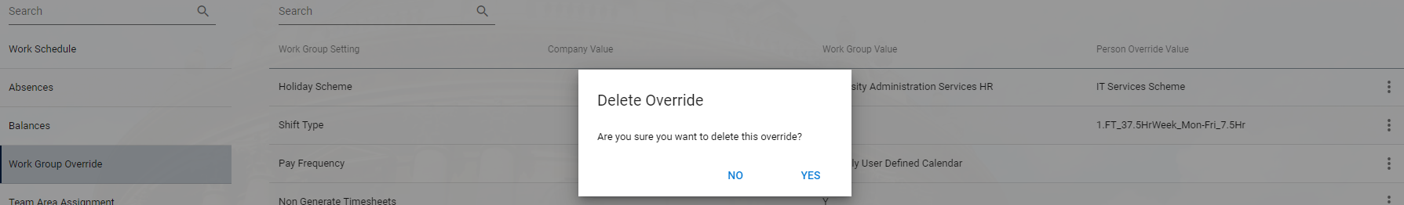

Maintain and Track Override

**Process to be determined**

